**City of Petra, Jordan**

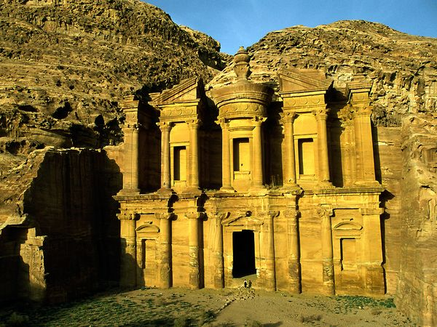

City of Petra is a historical city in Jordan famous for its rock cut architecture. Established in about sixth century BC as capital of Nabataeans, it has become the symbol of Jordan and one of the most visited tourist places in the world. Petra is part of New Seven Wonders of the World, UNESCO World Heritage Site and was selected by BBC as one of the 40 places you have to see before you die